

Mind Map & Performance Tracker

When you accomplish a one-time task, or begin a regular one in relation to the construction of your eBusiness, simply record it within the appropriate section of the performance tracker below.

This way, you’ll be able to see at a glance where you’re at and what’s coming up, while also reflecting on all the essential tasks that you’ve accomplished, whenever you wish.

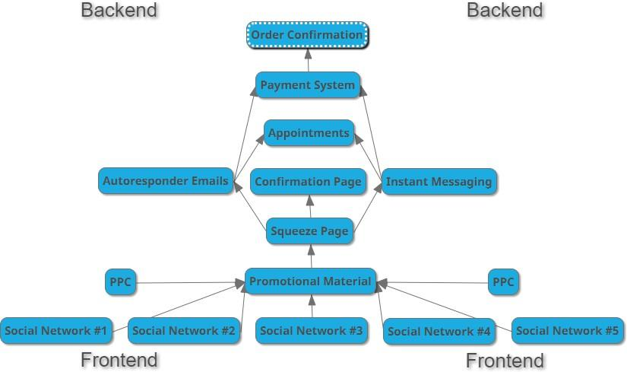

**Short-Term Objectives:**

















**Deadline:**



**Social Network #1** (network name)

One-Time Tasks Accomplished:

1.

Regular Tasks Initiated:

1.

**Social Network #2** (network name)

One-Time Tasks Accomplished:

1.

Regular Tasks Initiated:

1.

**Social Network #3** (network name)

One-Time Tasks Accomplished:

1.

Regular Tasks Initiated:

1.

**Social Network #4** (network name)

One-Time Tasks Accomplished:

1.

Regular Tasks Initiated:

1.

**Social Network #5** (network name)

One-Time Tasks Accomplished:

1.

Regular Tasks Initiated:

1.

**Promotional Material** (video/audio/image/text related posts)

One-Time Tasks Accomplished:

1.

Regular Tasks Initiated:

1.

**PPC** (pay-per-click campaign)

One-Time Tasks Accomplished:

1.

Regular Tasks Initiated:

1.

**Squeeze Page** (the landing page of your website)

One-Time Tasks Accomplished:

1.

Regular Tasks Initiated:

1.

**Confirmation Page** (appears immediately after the appointment form submission) One-Time Tasks Accomplished:

1.

**Autoresponder Emails** (notification/confirmation/reminders)

One-Time Tasks Accomplished:

1.

Regular Tasks Initiated:

1.

**Instant Messaging** (reminders/qualifying/neutralizing objections/rapport building) One-Time Tasks Accomplished:

1.

Regular Tasks Initiated:

1.

**Appointments** (online classroom & curriculum)

One-Time Tasks Accomplished:

1.

Regular Tasks Initiated:

1.

**Payment System** (near the end of your sales funnel)

One-Time Tasks Accomplished:

1.

Regular Tasks Initiated:

1.

**Order Confirmation** (CHA-CHING!)

One-Time Tasks Accomplished:

1.



© 2017 Rich Coaching